**HSS roll use conditions**

**Optimal improvement of production conditions：**

1. Rolling temperature: The temperature of the rolled steel entering the finished product rack is 1000~1050℃;

2. Cooling water parameters: water temperature ≤40℃, single rack water pressure 0.4~0.6Mpa, single rack water volume 24~30m³/hour, water quality chloride ion <200mg/L;

3. Cooling water pipe layout: annular cooling water pipe, the water nozzle covers the rolling groove, and the main nozzle is set to align with the rolling groove at the steel outlet. As shown below:

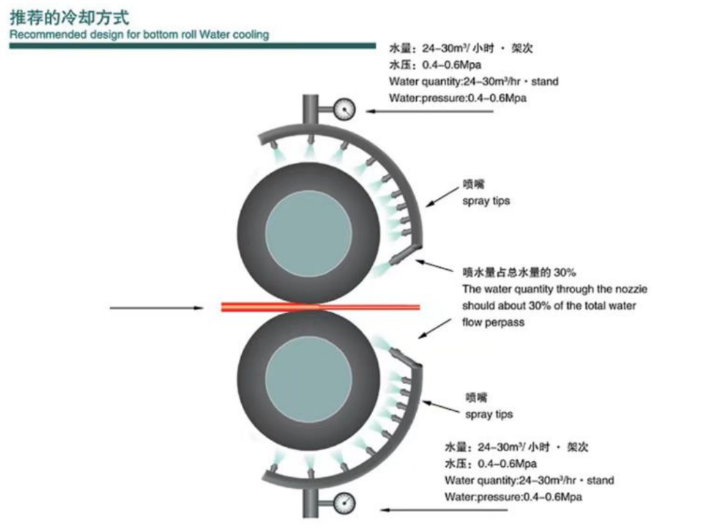

**If the on-site working conditions cannot meet the water pipe requirements in the above figure, improvements can be made according to the following figure.**

